Week 8 COMS30029 – Reflections

Reflecting on notions of interaction considering HCI Theory

Today we will reflect on the various theories of human-computer interaction that we have covered in the unit.

We will do this using the key notions and concepts of interaction as outlined by Hornbaek & Oulasvirta (2017) in their paper “What is interaction?”. Note: You are expected to have read at least the first 6 pages of that paper

Exercise 1
In your group, refer back to Table 1 from (Hornbaek & Oulasvirta, 2017), go over the table one row at a time, and discuss – now that we have covered a range of HCI theories in some detail – to what extent do the notions outlined in each row make sense to you, and to what theory or theories they make you think of?

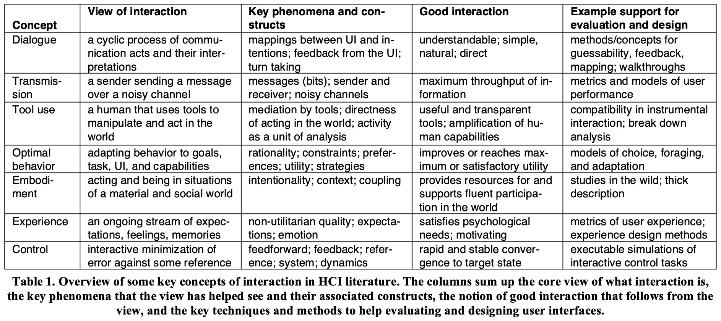

Exercise 2: In this HCI Theory unit we covered a lot of theory! Here is a summary:
- First Wave
  - KLM-GOMS
  - Fitts’ Law
  - Direct Manipulation
  - Gulf of Execution & Evaluation
- Second Wave
  - Affordances
  - Phenomenology
  - Distributed Cognition
  - Activity Theory
  - Situated Action
- Third Wave
  - Flow
  - Self-Determination Theory
  - Disability Studies
  - Health and wellbeing
- Fourth (?) Wave
  - Computational Interaction

Consider the following table, adapted version from Table 1 above. In your groups, think and discuss where you would “slot” the theories we have covered in this unit with regards to the notions and concepts of interaction outlined in the table. Do they all fit?

Concept | HCI Theory fit | Added value
Dialogue
Transmission
Tool use
Optimal behaviour
Embodiment
Experience
Control

